Delaware’s Forgotten World War II Hero:
Wilmer Earl Gallaher at Midway
Mark Weinberg
November 2025

- Introduction and Summary
The months after the devastating Japanese attack at Pearl Harbor were difficult ones for the United States. The Japanese had destroyed the cream of our Pacific Fleet and began a reign of conquest almost unparalleled in modern times: China, Singapore, French Indochina, the Philippines, the Dutch East Indies, New Guinea, Wake Island, etc. To fight back, the US had only its few precious aircraft carriers and the men who flew their planes.

Following the intelligence breakthroughs of the Navy’s codebreakers and Admiral Nimitz’s audacious confidence in their conclusions, the carriers were placed in position to neutralize the next Japanese attack on the strategic Midway Island. The pilots did the rest.

One of them was Lieutenant Wilmer Earl Gallaher, a Wilmington, Delaware native. He was Commander of Scouting Squadron Six (VS-6) aboard the USS Enterprise (CV-6). His skill, valor, and personal leadership directly helped sink two of the four Japanese aircraft carriers destroyed that day. This decisive result by the underdog Americans eliminated the threats to Midway, further Japanese expansion, and hundreds of irreplaceable first-line Japanese pilots. The Americans then began the long road to victory in the Pacific. Thus, a Delawarean was a key contributor to one of the most significant battles in world history. Yet, his role has been largely forgotten. We hope to begin to change that situation with this report.

- Biographical Information and Early Naval Career
Wilmer Earl Gallaher was born in Wilmington, Delaware on 9 May 1907 (Figure 1)¹. His parents were Albert Gallaher, age 32, and Julia Carr, age 24, living at the time at 846 Kirkwood Street, on the city’s east side. He was the only boy among three sisters: Virginia, 2 years older; Sarah, 1 year younger; and Elizabeth, 3 years younger.^{2.} Albert was a carpenter and later a millwright working in the chemical industry². By 1910, they had moved to 219 Franklin Street and by 1920, they were at 405 W. 31 Street, all in Wilmington.
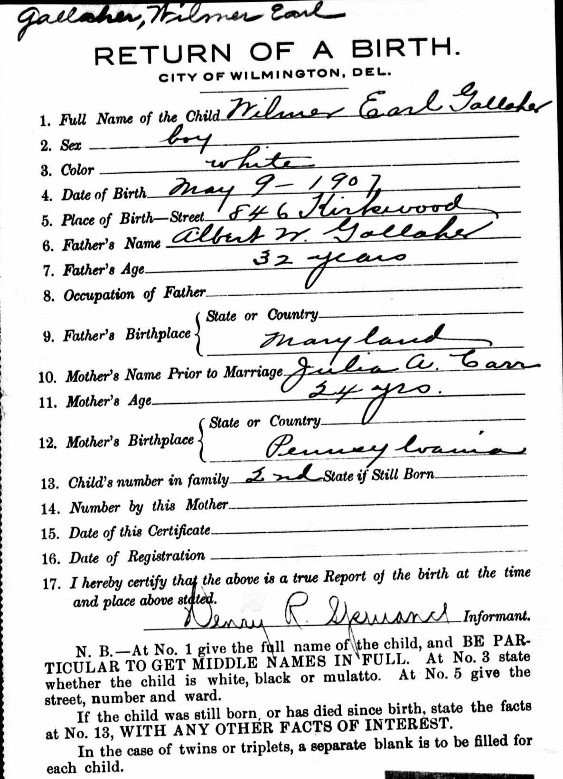
Figure 1: Gallaher Birth Record¹

Gallaher went to Schools 23 and 24 and Wilmington High School. According to Bill Frank, long-time feature columnist for the Wilmington News Journal and its predecessors, he dropped out in his junior year of 1924³ (Appendix 1). He enlisted in the Navy 23 February 1926 and was trained at Newport, Rhode Island and at the Radio School at Hampton Roads, Virginia. He had to go back to high school when he learned of the requirements for the US Naval Academy. He took the entrance exams in April 1927 and was accepted to the Academy in May. His parents were living in the Richardson Park section of Wilmington by then and the neighborhood was thrilled to hear the news⁴.
He must have been quite the ladies’ man based on his Academy nickname of “Lovey”⁵ (Figure 2). The Gym Team was a major interest. In fact, “Dusty” Kleiss, later to be in his squadron, said that he nearly won a spot on the 1928 US Olympic Team.⁶ He graduated in the class of 1931.
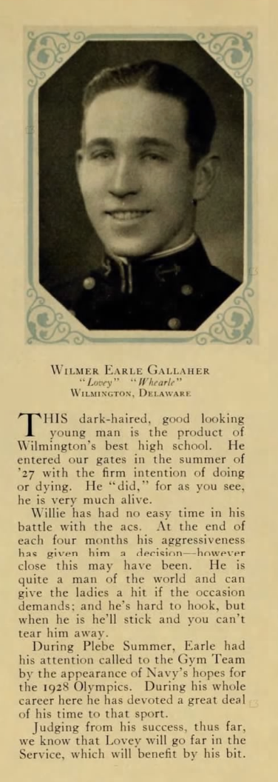
Figure 2: Gallaher at the USNA, 1931⁵
Upon joining the fleet, Gallaher served on the ill-fated battleship USS Arizona (BB-39) and destroyer USS Barney (DD-149) before entering Pensacola for flight training in 1933.⁷ After receiving his wings in 1935, he served on both the USS Langley (CV-1), the first American aircraft carrier, and the USS Ranger (CV-4).⁷
He married Annette Woods 31 October 1934 in Pensacola⁸ and had one son with her, William A. Gallaher, born in 1939. He also had a daughter, Florence Ann Gallaher, born in 1930 and thus, probably from a previous relationship of Annette’s. The Gallahers divorced 22 December 1955 while he lived in Alexandria, Virginia.⁹

- Early War Experiences
When war broke out, Gallaher was assigned to the USS Enterprise (CV-6) as Executive Officer of Scouting Squadron 6 (VS-6), flying Douglas SBD-3 Dauntless dive bombers. Gallaher was well respected in the unit. “Dusty” Kleiss wrote:

“I liked him instantly. He possessed a friendly demeanor and had excellent skill. Undoubtedly, Gallaher had the best aim of any of the dive bomber pilots in the Navy at the time. He was easily the true genius of our squadron.”⁶

Gallaher was flying over Hawaii and Pearl Harbor during the Japanese attack on 7 December. He saw the devastation and fought back against the enemy planes.

Enterprise was at sea and was supposed to have been back at Pearl on 6 December. However, it was luckily delayed due to bad weather. The air group of carriers usually returned to land-based airfields when the carriers were in port. Thus, Gallaher was leading a flight when he saw planes flying over Oahu. He first thought they were U.S. Army planes since they would often have mock battles with each other, though it would be unusual for a Sunday morning and without advanced warning. It was then that Japanese Zero fighters began attacking and he saw smoke rising from the harbor. His radioman began to fire at the planes with red balls (“meatballs”) on the side that proved they were Japanese. He radioed “Pearl Harbor is under attack.” He claimed that he didn’t add the rest of the famous message that was rebroadcast to the world: “This is no drill”, but rather “This is no [expletive]”. He landed at a Marine Corps base, Ewa Field, and was told: “get the hell off the ground. Can’t you see what’s going on, the planes are burning all over the field”. He then took off and flew to Ford Island, as he usually did. However, the ground forces started firing at the incoming American planes. A number were unfortunately shot down.¹⁰

He saw the wreckage in the harbor and said that he was

“very, very, very upset because the Arizona had been my first ship in the Navy as an ensign, and the Arizona had taken the worst licking. I was very, very upset about that”.¹⁰

He and eight others later took off on a bombing run to attack the Japanese ships. However, none were found.¹⁰

Enterprise then participated in several hit-and-run raids in early 1942. The first U.S. carrier strike of the war was against Roi and Kwajalein of the Marshall Islands on 1 February 1942. Gallaher successfully hit the stern of a cruiser off Kwajalein.^{10,11} He became leader of Scouting 6 when LCDR Hopping was shot down.¹² Gallaher’s gunner, RM 1/C Thomas Merritt, then shot down the Japanese plane that had shot down Hopping.¹³ Kleiss said that “…Gallaher was a superb replacement. He led us by example. He demanded perfection and he got it.”¹²

The next raid on 23 February was on the former U.S. territory Wake Island.

While the results of these raids were minimal, they had a psychological effect on the Japanese, and a positive effect on American morale. Importantly, the pilots gained essential battle experience, but at the expense of a significant loss of pilots. Only eight of the original nineteen pilots who had left San Diego in May 1941 still served by March 1942.¹⁴

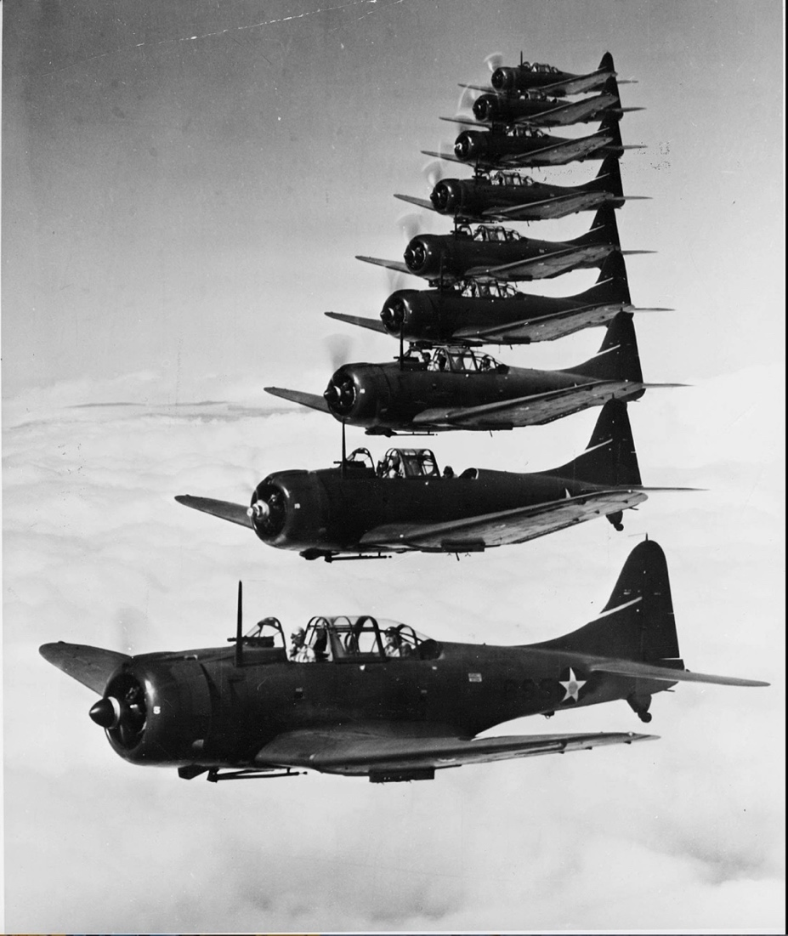
Figure 3: Scouting Six in Formation, 17 October 1941¹⁵

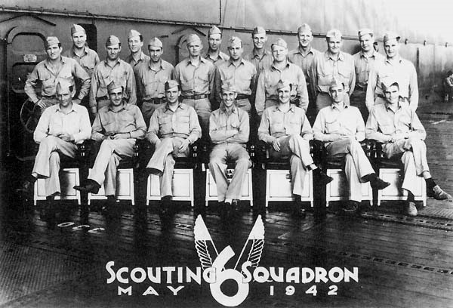
Figure 4: Group Photo of Scouting Squadron 6 (VS-6), 12 May 1942, about one month before the Battle of Midway¹⁶ .
Seated (L-R): Lt (jg) J. Norman West, Lt Frank A. Patriarca, Lt Charles R. Ware, Lt Wilmer E. Gallaher (CO), Lt Clarence E. Dickinson, Jr., Lt (jg) Norman J. "Dusty" Kleiss, ENS John R. McCarthy, AV(N).
Second row (standing) (L-R): ENSs [all A-V(N)] John Q. Roberts, Carl D. Peiffer, James A. Shelton, William R. Pittman, John c. Lough, Vernon L. Micheel, Eldor E. Rodenburg, Thomas F. Durkin, Jr., Richard A. Jaccard, Frank W. O'Flaherty, Clarence E. Vammen, Jr., James C. Dexter, Reid W. Stone, William P. West.

- The Battle of Midway: Rationale and Preliminary Issues
Since the Battle of Midway was one of the seminal battles in world history, it is no surprise that there have been many books written and movies made about it, including a documentary actually filmed during the Japanese bombing of Midway Island by celebrated director John Ford. Thus, we will only summarize the basics here and in the next section, focus on Gallaher’s specific role.
The Japanese wanted Midway Island to expand its defensive perimeter, but most importantly, to lure the American fleet into a decisive battle that would force the Americans to negotiate a peace treaty. This plan was put into place earlier than desired due to the Doolitle Raid on 18 April 1942.¹⁷ This audacious mission involved land-based B-25 bombers flying from an aircraft carrier, USS Hornet (CV-8), to bomb Japan. It caused little real damage, but was another psychological blow and humiliation to the Japanese.
While the Japanese sank the U.S. aircraft carrier USS Lexington (CV-2) and heavily damaged the carrier USS Yorktown (CV-5) in the Battle of the Coral Sea, 4-8 May 1942, two Japanese carriers, Shokaku and Zuikaku, were also heavily damaged and not available for Midway. This meant that there would only be four carriers instead of the planned six. Nonetheless, the Japanese still had a numerical advantage in carriers.
What the Americans did have was advance knowledge of the attack due to their breaking of the Japanese code. Initially, all they knew was the target was “AF”, but weren’t sure what “AF” was. The staff famously devised a stratagem to have Midway feign not having fresh water and report that with an unencrypted message. When they decoded a Japanese message saying, “AF is short of water”, the target identity was confirmed.
Boldly accepting the intelligence as to the time and place of the attack and risking the remaining Pacific aircraft carriers, Admiral Chester Nimitz, commander of the U.S. Pacific Fleet, prepared a plan to station the carriers northeast of Midway. This position would place the smaller American fleet out-of-range of Japanese patrol planes, but allow an attack on the Japanese from an unexpected position.
The other major issue was the status of the Yorktown. As indicated above, she had been heavily damaged at the Coral Sea, but was able to reach Pearl Harbor. The initial estimates were that it would take months to repair her. Nimitz gave the shipyard 72 hours. Amazingly, the yard was able to do enough so that Yorktown was available with Enterprise and Hornet to meet the Japanese. Nonetheless, it would still be four Japanese carriers to three for the Americans.¹⁸

- The Battle of Midway: Gallaher's Critical Role in the Carrier Strikes (See Appendix 2 for Gallaher’s contemporaneous mission report)

  - The Morning Attack

On 28 May 1942, Task Force 16 with Enterprise and Hornet left Pearl Harbor. Though Admiral Halsey was no longer in charge of the operation due to a severe case of dermatitis, Kleiss said that:
“Gallaher knew a little more about the upcoming operation than most pilots on Enterprise. Years earlier, he had dated Halsey’s daughter, Margaret.”¹⁹
Based on the broken code and subsequent intelligence, American reconnaissance planes began searching the expected area on 4 June 1942. As both predicted and hoped for, the Japanese fleet was spotted. Gallaher and his fellow pilots were ready to be launched. He felt:
“the feeling of anticipation, more than any kind of fear or anything like that, the anticipation of the fact that we were really gonna have the chance, this was my feeling and I know the feeling of many of the pilots, of paying them back for Pearl Harbor.”¹⁰
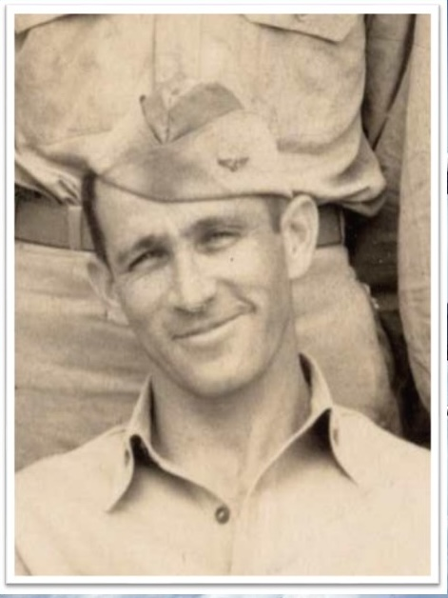
Figure 5: Gallaher at Midway²⁰
In the meantime, Admiral Nagumo, commander of the Japanese fleet, launched his strike on Midway Island. The attack did considerable damage, but did not put its airfield out-of-commission and end the threat of land-based planes. Thus, a second strike was needed and the planes that had been armed with torpedoes to attack any American ships had to be rearmed with bombs. This was a non-trivial operation that took considerable time. It is important to note that Nagumo’s understanding of the tactical situation was significantly clouded by a series of uncoordinated American attacks from Midway and incomplete reports from his own reconnaissance aircraft. When the American ships were finally spotted, Nagumo’s planes had to be rearmed with torpedoes because of the bigger carrier-based threat. His planes from the Midway attack also needed to land. This took more time.
Then, the first of the carrier-based American planes arrived: Torpedo Squadron 8 (VT-8) from Hornet commanded by LTCR John Waldron. It was a suicide run: flying slowly and steadily, at low altitude, with no fighter escort, and with torpedoes that tended to not work. No damage was done. All fifteen planes were shot down and only one pilot survived, ENS. George Gay. He was famously able to stay afloat to observe the rest of the American attack and be rescued. Torpedo Squadron 6 (VT-8) from Enterprise was next to sacrifice themselves. Nine of fourteen planes were shot done.
What the heroism of the torpedo squadrons did accomplish was to bring the Japanese fighters to low altitudes and open the skies to the dive bombers that were on the way.
However, the Japanese fleet was not in the position the dive bombers expected. When LTCR Wade McClusky, Enterprise's air group commander, could not find them, and with his air group's fuel running low, he began a search and soon spotted a Japanese destroyer steaming fast. Assuming that she must be following the main fleet, McClusky ordered a change in course to follow. This led him directly to the enemy carriers and the attack.
McClusky’s bomb missed, but Gallaher had what he called “the perfect dive” and squarely hit the Kaga. Then Gallaher:
“couldn’t resist the temptation” and did what he had warned his men not to do: “kind of stand your plane on its tail and watch the bomb hit.” His radioman said, “god damn, that was a beaut captain.”¹⁰
“For Gallaher, this was a particularly poignant moment. It was revenge for his fellow Scouting Six pilot Johnny Vogt, who had been shot down over Pearl Harbor. It was revenge for the destruction wrought on the battleship USS Arizona that day, the aftermath of which Gallaher had witnessed and would never forget. ‘Arizona’, he said to himself as his bomb struck home, ‘I remember you.’”²¹
Other bombs landed on Kaga, including one by Kleiss. Figure 6 shows a painting of the attack.
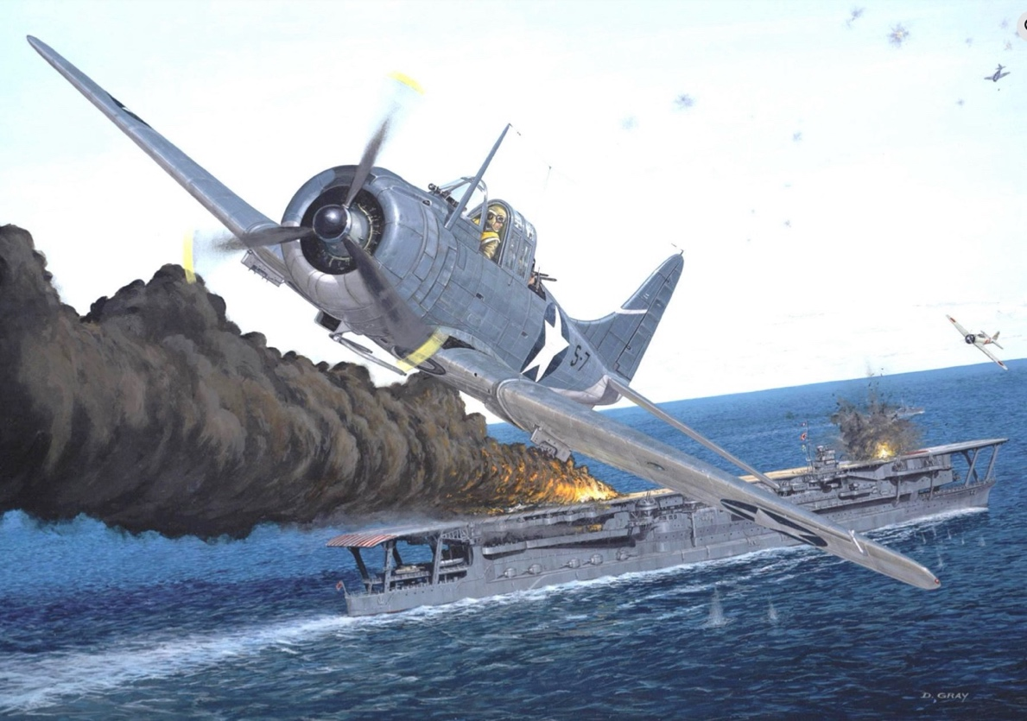
Figure 6: Aviation artist David Gray's depiction of LT. Dusty Kleiss's diving attack on Kaga, LT Earl Gallaher scored the first hit. (The flaming wreckage near the stern represents his bomb strike.) Dusty scored the second hit. (His bombs--one 500-pounder and two 100-pound incendiaries--are going off near the bow the carrier.) LT Clarence Dickinson scored the third hit (also amidships, possibly near the bridge), and ENS George Goldsmith scored the last hit, striking Kaga with a 1,000-pound bomb.²²
Three VB-6 dive bombers from Enterprise under the command of LCDR Richard (Dick) Best soon hit Akagi, Nagumo’s flagship. Other dive bomber squadrons from Yorktown (VB-3), commanded by LCDR Max Leslie, hit Soryu.
In a few minutes, three of the four Japanese carriers were aflame and on their way to the ocean floor. Kleiss said, “Three frontline Japanese aircraft carriers were huge bonfires, flaming like Kansas straw stacks.”²³ The bombing accuracy was impressive: “Twenty-seven pilots attacked Kaga and four scored hits. Three attacked Akagi and one scored a hit. Nine attacked Soryu with three scoring hits.”²⁴

The long search and battle had used a lot of fuel. Several of the pilots ran out and had to ditch. Not all were rescued. Of Gallaher’s squadron, eight of fifteen returned, two others ditched and were rescued, and six were unaccounted for (Appendix 2).

  - The Afternoon Attack on the Hiryu

Despite the destruction, there was one Japanese carrier still left, the Hiryu. In fact, Hiryu’s planes successfully bombed Yorktown twice, which eventually was sunk by a Japanese submarine. Scouting planes located Hiryu in the afternoon and the pilots prepared for another strike. Enterprise’s air group commander, McCluskey, had been wounded in the morning operation. Gallaher was the most senior of the remaining pilots and thus, was given command. Kleiss wrote:
“I was overjoyed to hear our superb skipper would be leading us. Gallaher’s leadership shined immediately. He drew up a plan that differed greatly from the morning attack. Instead of wasting time trying to unite the air groups, Gallaher wanted Enterprise to launch its dive bombers and not wait for Hornet’s air group to unite. This way my squadron could conserve its fuel, we could take our time when making our attacks, and we didn’t have to worry about coordinating with other groups.”²⁵
Enterprise deployed twenty-four dive bombers: six from VS-6 (Enterprise), four from VB-6 (Enterprise), and fourteen from VB-3 that had flown off the sinking Yorktown. While the morning mission took three hours to find the Japanese, this one only took ninety minutes. Gallaher went first to bomb, when Hiryu suddenly made a sharp turn. He tried to compensate, but wrenched his back in the process. He missed; others, including Kleiss, did not. Hiryu “looked like a big smoking taco”²⁶ and was doomed.
Gallaher was lucky he was able to land. His back injury initially prevented him from reaching the tailhook lever. Without that activated, nothing would stop the plane from rolling down the deck into the sea. Somehow, he was able to overcome the pain and pull the lever. Gallaher had to be lifted out of the plane and sent to sick bay.
Gallaher’s battle was over, though not for his squadron which continued to fly missions over the next two days. He continued to worry about them:
“At night, when the kids were coming in, I was supposed to be in bed, but I was up on the deck and I squeezed them aboard, every one of them.”¹⁰

- The Aftermath
Gallaher was awarded the Navy’s top combat award, the Navy Cross, for his actions at Midway (Figure 7)^{7,27}. The award read in part²⁸:
“Participating in a devastating assault against a Japanese invasion fleet, Lieutenant Gallaher, with fortitude and resolute devotion to duty, pressed home his attacks in the face of a formidable barrage of anti-aircraft fire and fierce fighter opposition. His courageous aggressiveness and inspiring leadership were contributing factors to the success of our forces and were in keeping with the highest traditions of the United States Naval Service.”

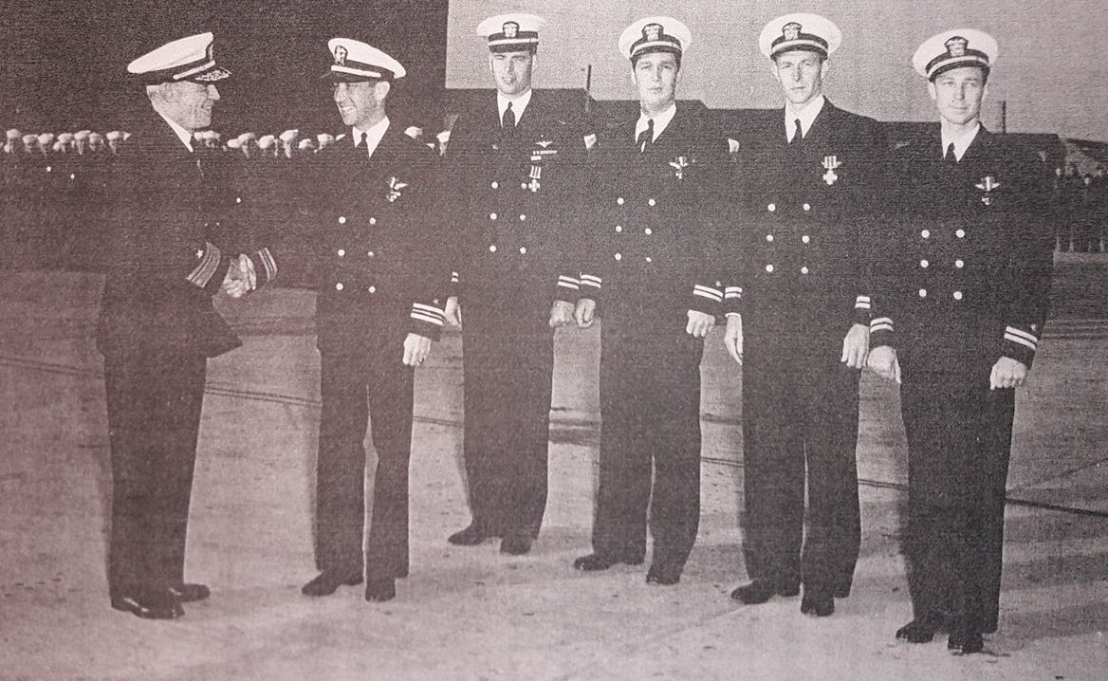
Figure 7: Navy Cross Ceremony held at Bronson Field, an auxiliary airfield located outside of Pensacola on November 28, 1942. Rear Admiral George D. Murray, the former commander of USS Enterprise, hands out the medals. Murray is shaking hands with now LCDR Wilmer Earl Gallaher. Fourth from the right is LT James Seton Gray, former commander of Fighting Squadron Six, who received a gold star on his Distinguished Flying Cross. Next to Gray (and third from the right) is LT Irvin H. McPherson, a pilot who belonged to Torpedo Squadron Six. McPherson was one of only five VT-6 pilots who survived the battle. Next to McPherson is LT Thomas Clinton Provost III, formerly of Fighting Squadron Six. At Midway, LT Provost shot down LT Michio Kobayashi, the commander of Hiryu's dive bombers. Finally, the one on the far right is LT Nels Luther Alvin Berger, formerly of Scouting Five. At Midway, Berger participated in the diving attacks on the destroyer Tanikaze (damaged) and the heavy cruiser Mikuma (sunk).²⁷
Previously, he had been commended by Navy Secretary Frank Knox for the raid on the Marshall Islands and received a letter of commendation for his participation in the Wake Island attack.²⁹
Gallaher returned home to Wilmington on 14 August 1942 and was the keynote speaker at the Naval Aviation Rally at his alma mater, Wilmington High School.²⁹ He was given a tremendous ovation by the audience of 300 people and told them that “that attack on the carrier was what he had been waiting for. ‘I had been dreaming of it since the war started.’”
Gallaher became commanding officer of the Naval Air Station at Pensacola in July 1943.³⁰ By May 1944, he was executive officer of an aircraft carrier in the Philippines and Okinawa.^{3,30,31}
He remained in the Navy after the war and had a series of staff positions, starting with the Naval War College.^{3,31} During the Korean War from 16 July 1951 to 9 July 1953, he was Commander Naval Forces Far East, for which he received the Legion of Merit.²⁸
Two sea assignments followed: captain of the sea plane tender USS Kenneth Whiting (AV-14) from July 1953 to June 1954³² and captain of the aircraft carrier USS Princeton (CVS-37) from 14 January 1956 to 19 January 1957 (Figure 8).^{7,} ³³
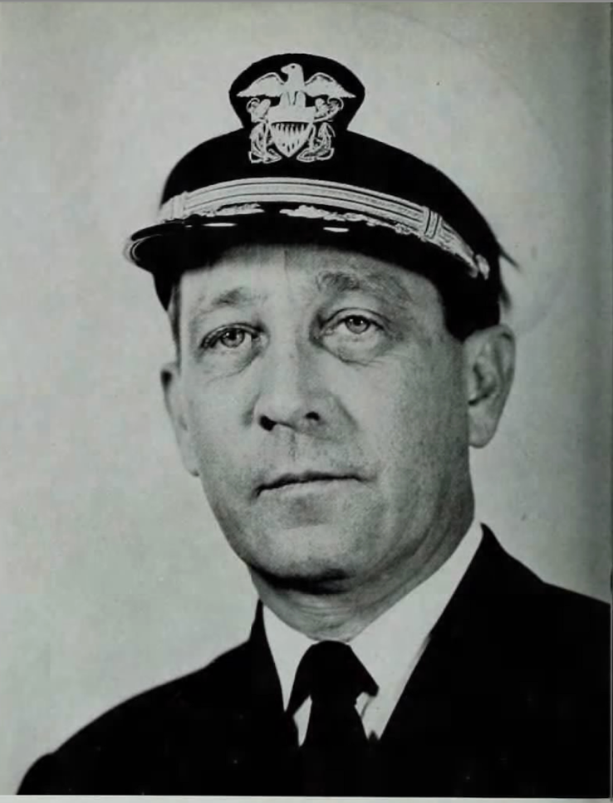
Figure 8: Command Photo, USS Princeton, 1956⁶

On a personal note, he married Caro Miller on 25 August 1956 in San Diego, California.³⁴
His final posting was as a liaison officer to the Supreme Allied Commander, Atlantic. Gallaher retired from the Navy in 1959, upon which he was promoted to rear admiral.¹⁰
He died of cancer 4 February 1983 at the Bethesda Naval Hospital and was buried at the Arlington National Cemetery, Arlington, Virginia³¹ (Figure 9). As Bill Frank wrote, “The funeral…was attended by an unusually large number of high ranking naval officers.”³ (Appendix 2). He was survived by his wife Caro nee Miller, son Albert, and a sister, Elizabeth Sharman, still living in his Wilmington Delaware hometown.

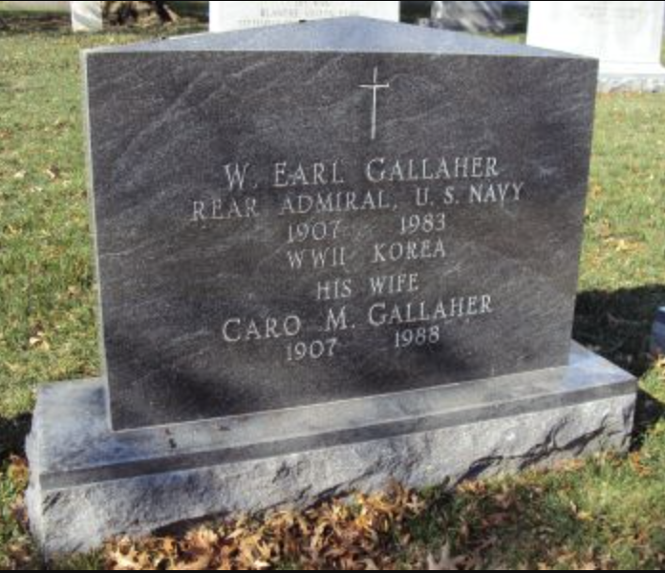
Figure 9: Internment, Arlington National Cemetery³⁵

- Legacy

  - The Battle

There is no question that the Battle of Midway is remembered by history as the turning point of the Pacific war. Prior to it, the Japanese had appeared unstoppable. After, Japan’s ability for large-scale offensive operations was crippled. It did not have the capacity to replace either the aircraft carriers or the highly-trained pilots.
This dramatic change in fortune was due to a combination of things. A full analysis and literature survey are beyond the scope of this report. Yet, it is illustrative to summarize the thoughts of “Dusty” Kleiss, a key VS-6 participant in the battle and friend of Gallaher. He believed that credit should go to the skill and training of the pilots, the martyrdom of the torpedo bomber squadrons flying on a “suicide mission”, and the quality of the SBD-3 dive bomber.³⁶
He also believed that the admirals get too much credit. However, without the American code breaking skill, the confidence Admiral Nimitz had in the subsequent intelligence, and the risk Nimitz took in placing ALL the Pacific carriers near Midway, the pilots would not have been in position to do their work.
Finally, Kleiss discounted the “luck theory” of the timing that he said cheapens what the aviators accomplished. Clearly, the outcome would have been different if the dive bombers had come at a different time from when the Japanese planes were rearming and refueling on deck and the torpedo planes had brought the Japanese combat air patrol down to low altitudes. Yet, there is an old saying that “serendipity rewards the prepared mind”. Perhaps this saying can reconcile the two views because the American dive bomber pilots were sufficiently trained and prepared to take advantage of the opportunity.
And yes, the battle pivoted on the events over a very short time window. Mitsuo Fuchida, Japanese pilot on board Akagi during the battle and leader of the first wave at Pearl Harbor is quoted by Simms and McGregor as saying:
“Five minutes! Who would have dreamed that the tide of battle would shift completely in that brief interval of time?”³⁷

  - Wilmer Earl Gallaher
How does history remember Wilmer Earl Gallaher? Despite his prominent role in the battle, and the effusive praise of him by “Dusty” Kleiss, he is largely forgotten by all but War II buffs and historians. When Gallaher passed away in 1983, Bill Frank of the Wilmington News Journal wrote a piece entitled “Once again Delaware has forgotten one of Its outstanding heroes”. This article is given in its entirety in Appendix 1. Frank pointed out that Gallaher’s obituary in his hometown newspaper was only 4 paragraphs long. It trivialized his actions as:
“During World War II, he served at Pearl Harbor and Midway, and in several other battles. He had worked most recently as an instructor for Northwestern High School’s Junior Naval ROTC program.”³⁸
How demeaning!
Gallaher never wrote a book like Kleiss did towards the end of his life, so unfortunately, the subsequent 42 years have not changed this situation. Gallaher doesn’t even have a Wikipedia page!
Another Delaware World War II hero, George S. Welch, had an elementary school named for him at the Dover Air Force Base. Welch was one of the few American pilots to fly at Pearl Harbor and shoot down Japanese planes.³⁹ Ironically, there actually is a Gallaher Elementary School in Newark, Delaware. However, it is named for someone else, Robert S. Gallaher, former president of the Newark School Board.⁴⁰
The one place Gallaher is publicly feted is at the National Museum of the Pacific War, Fredericksburg, Texas⁴¹. A display there includes items he wore during the battle (Figure 10).
Perhaps this report will jumpstart efforts to get proper recognition for one of Delaware’s greatest modern heroes. Both the 85th anniversary of Midway and the 120th anniversary of his birth are in 2027. With the last of the “Greatest Generation” passing away, it is finally time for him to get his long overdue recognition.
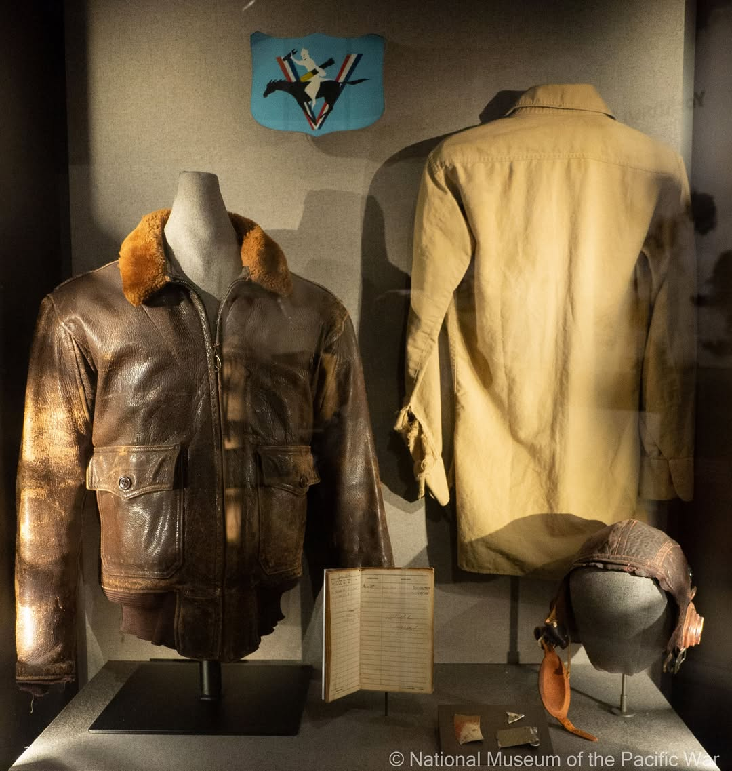
Figure 10: Gallaher’s Midway Flight Jacket, Shirt, Helmut, and Logbook on display the National Museum of the Pacific War, Fredericksburg, Texas⁴¹

VIII. Appendices
A. Bill Frank Article³
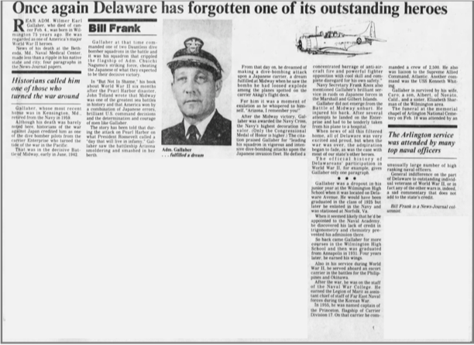

B. Scouting 6 Action Report – 4-6 June 1942 (Contemporaneous), LT Earl Gallaher⁴²
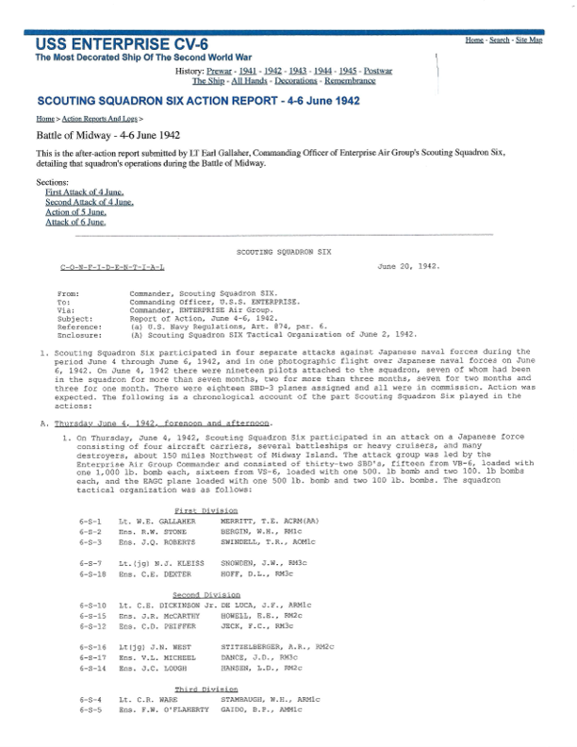
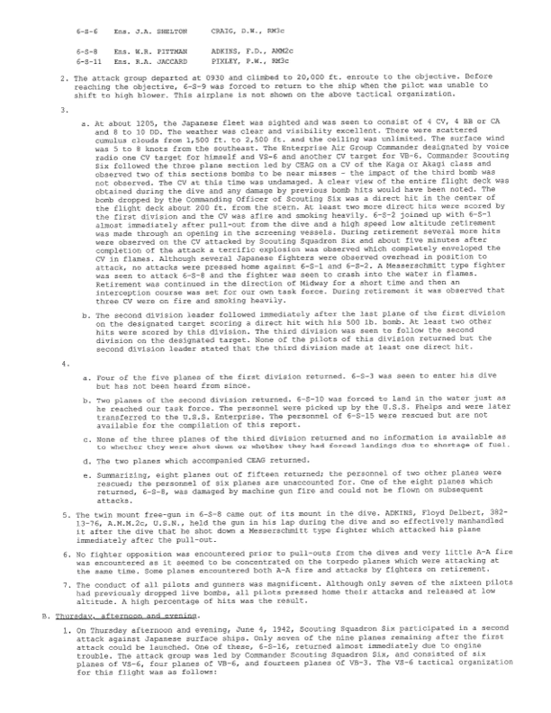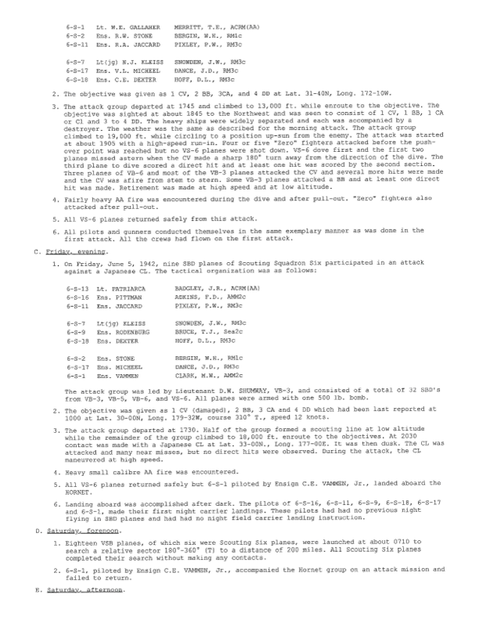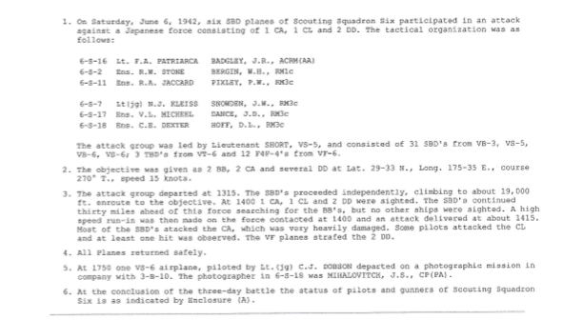

- References
. Birth Record, City of Wilmington, Delaware, https://www.ancestry.com/search/collections/1672/records/92130?tid=&pid=&queryId=d79004e1-7b9c-4ff6-a19d-30554b4f22e5&_phsrc=wot2042&_phstart=successSource; downloaded 10/27/25
2. 1910 and 1920 US Censuses, https://www.ancestry.com/search/collections/7884/records/151702151, https://www.ancestry.com/search/collections/6061/records/82134367, downloaded 10/27/25
3. The Morning News (Wilmington, Delaware), Tuesday, February 22, 1983, Page 6 https://www.newspapers.com/image/161114764/; downloaded September 12, 2025
4. The News Journal (Wilmington, Delaware), Tuesday, May 17, 1927, Page 1, https://www.newspapers.com/image/161095567/; downloaded October 22, 2025
5. Military Yearbook, USNA, 1931, https://www.fold3.com/image/705392397/1931-page-260-military-yearbooks, downloaded October 22, 2025
6. Kleiss, N. Jack “Dusty”, Never Call Me a Hero, Harper-Collins, 2017, page 79
7. USS Princeton Cruise Book, 1956; https://www.fold3.com/image/705055851/1956-page-255-us-navy-cruise-books-1918-2009; downloaded October 22, 2025
8. Florida Marriage Indices, https://www.ancestry.com/search/collections/8784/records/505256; downloaded October 22, 2025
9. Virginia Divorce Records, https://www.ancestry.com/search/collections/9280/records/1736099?tid=&pid=&queryId=10da401a-c585-4a94-a3d3-61b842fcfa68&_phsrc=wot2030&_phstart=successSource; downloaded October 22, 2025
10. World War II Database, Brosnahan, Jim, Interview with Earl Gallaher, 4 June 1992, https://ww2db.com/doc.php?q=403, downloaded October 22, 2025
11. Kleiss, page 141
12. Kleiss, page 155
13. Kleiss, page 136
14. Kleiss, page 165
15. Kleiss, photos
16. Heroes of the United States Naval Academy Facebook Group https://www.facebook.com/photo/?fbid=658112123021241&set=pcb.658101846355602, Downloaded October 22, 2025
17. Simms, Brendan and McGregor, Steven, The Silver Waterfall, Public Affairs, 2022, pages 61-63
18. Battle of Midway, Wikipedia, https://en.wikipedia.org/wiki/Battle_of_Midway, downloaded October 24, 2025
19. Kleiss, page 177
20. Never Call Me a Hero Facebook Group, https://www.facebook.com/photo/?fbid=2626684517432585&set=a.1034771733290546, downloaded October 22, 2025
21. Simms and McGregor, pages 156-157
22. Never Call Me a Hero Facebook Group, https://www.facebook.com/photo/?fbid=1645420755558971&set=a.1034771733290546; downloaded October 22, 2025
23. Simms and McGregor, pages 166-167
24 Kleiss, page 205
25. Kleiss, page 216-217
26. Kleiss, page 222
27. Never Call Me a Hero Facebook Group, https://www.facebook.com/photo/?fbid=1571561606278220&set=a.1034771733290546, downloaded October 22, 2025
28. Hall of Valor by Military Times, Wilmer Earl Gallaher, https://valor.militarytimes.com/recipient/recipient-21244/, downloaded October 24, 2025
29. The Morning News (Wilmington, Delaware), August 15, 1942, https://www.newspapers.com/image/160812364/, and August 14, 1942, https://www.newspapers.com/image/160812048/, both downloaded September 12, 2025
30. The News Journal (Wilmington, Delaware), Friday, 12 May 1944, https://www.newspapers.com/image/161809742/?match=1&terms=sharman, downloaded October 25, 2025
31. “Retired Rear Adm. W. Earl Gallaher Dies”, Washington Post, February 8, 1983, https://www.washingtonpost.com/archive/local/1983/02/09/retired-rear-adm-w-earl-gallaher-dies/2fd0ba22-f8a1-43b7-a81d-3f78fe82718c/, downloaded October 24, 2025
32. NavSource Online: Service Ship Photo Archive, USS Kenneth Whiting (AV-14), https://www.navsource.net/archives/09/41/4114.htm, downloaded October 25, 2025
33. http://wings-aviation.ch/22-USNavy-Carrier/Fleet-Carrier/37/USS-Princeton.htm, downloaded October 25, 2025
34. Ancestry.com, https://www.ancestry.com/search/collections/5186/records/1398092?tid=&pid=&queryId=b5456866-b333-4548-9193-4fc7c6694d40&_phsrc=wot2034&_phstart=successSource, downloaded October 5, 2025
35. Find A Grave, https://www.findagrave.com/memorial/98410255/wilmer-earl-gallaher, downloaded October 24, 2025
36. Kleiss, page 279-282
37. Simms and McGregor, epigraph
38. The Morning News (Wilmington, Delaware), Tuesday, February 8, 1983, https://www.newspapers.com/image/161752885, downloaded September 12, 2025
39. “About Major George S. Welch”, https://wel.crk12.org/about-cr/school-profile, downloaded October 28, 2025
40. School History, Robert S. Gallaher Elementary School, https://www.christinak12.org/Page/4977, downloaded October 27, 2025
41. Scouting Six Action Report-4-6 June 1942 (Contemporaneous), http://cns74238.hostwindsdns.com/ship/logs/action19420604-vs6.htm, downloaded October 28, 2025

